FRONT COVER:

Terms and Conditions

LEGAL NOTICE

The Publisher has strived to be as accurate and complete as possible in the creation of this report, notwithstanding the fact that he does not warrant or represent at any time that the contents within are accurate due to the rapidly changing nature of the Internet.

While all attempts have been made to verify information provided in this publication, the Publisher assumes no responsibility for errors, omissions, or contrary interpretation of the subject matter herein. Any perceived slights of specific persons, peoples, or organizations are unintentional.

In practical advice books, like anything else in life, there are no guarantees of income made. Readers are cautioned to reply on their own judgment about their individual circumstances to act accordingly.

This book is not intended for use as a source of legal, business, accounting or financial advice. All readers are advised to seek services of competent professionals in legal, business, accounting and finance fields.

You are encouraged to print this book for easy reading.

Table Of Contents

Foreword
Chapter 1:
Reptile Care Basics

Chapter 2:
Research The Correct Temperature

Chapter 3:
What Kind Of Environment Does The Reptile Need

Chapter 4:
What Kind Of Food Does Your Reptile Need

Chapter 5:
Make Sure You Clean Up After Your Pet As Required

Chapter 6:
The Problems With Not Caring For Your Reptile Properly

Wrapping Up

Foreword

Getting to know a little more about reptiles and the basic care required would help the individual make decisions on its suitability as pets. This is often necessary, as reptiles are not really considered a common choice for a pet; therefore there is not a lot of supporting material easily available on them for the individual deciding to have one as a pet.. Get all the info you need here.

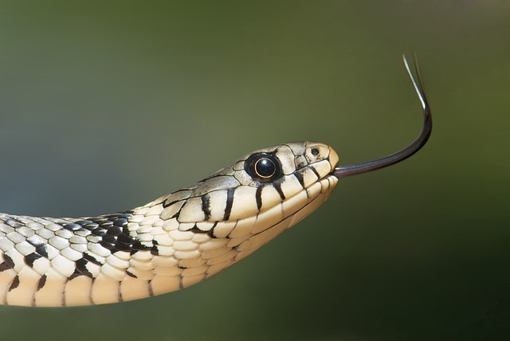

Slithery Creature Care
The Basics Behind Reptile Care

Chapter 1:
Reptile Care Basics

Synopsis

The following are some tips that can shed some light on the reptile care basics and the various elements to consider when acquiring one:

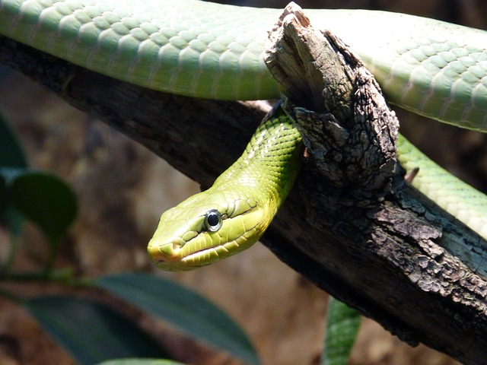

The Basics

Learning as much as possible about reptiles would allow the individual to be more informed on whether the choice made would be a suitable fit into his or her current lifestyle.

As there are commonly three basic categories of reptiles suitable as pets, the care given would very much centre on the distinct requirements of the corresponding category the pet falls into. These categories would include the handleable, semihandleable and the visual.

Identifying the type of reptile suitable as a pet should be the first step in a succession of step that should ideally follow of which the corresponding care is also clearly identified. This will then allow the individual to make all the necessary arrangements to provide for the reptile pet.

Checking on the reptile pet daily will help to keep the owner alert to any changes in behavior or eating patterns. These changes will help the individual to take the corresponding measures to ensure the pet is back at its optimal condition again.

Generally reptiles do require cool and moist surroundings; this should be accommodated as much as possible to ensure its comfort and longer lifespan. Failing which its skin could become dry and other medical problems may arise and cause a host of other problems.

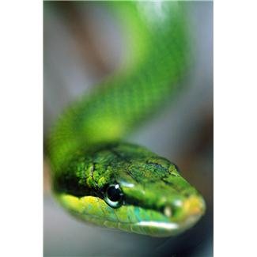

Chapter 2:
Research The Correct Temperature

Synopsis

The reptile pet would need to have ideal living conditions in order to survive comfortable and without the adequate knowledge on the varying temperatures required, it is more than likely the reptile will suffer the consequences which could range from mild to dangerous.

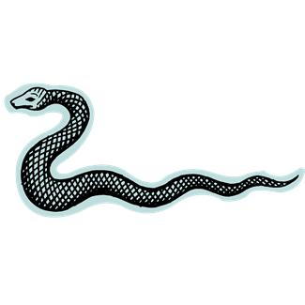

Do The Research

In the wild, these animals are able to regulate their body temperature by finding and using outside elements to assist them as they are not created with a system that regulates itself.

Therefore these reptiles would search for the ideal conditions and settle in comfortably until there is a need to move again should the body temperature or the surrounding temperature change. When it comes to the confines of the pet’s enclosure, this may be rather hard to do.

For one the space available would be really very limited and for the other, there would not be enough “ideal” conditional changes due to the limited space. Therefore the reptile would not be able to move to the next best location when the need arises.

This will cause the reptile to react unfavorably and even eventually affect its overall health. Some owners are sensitive to this need and take the trouble to simulate as much as possible the requirements that would provide for suitable temperature changes, while other owners would fail to take this into consideration simply out of ignorance or sheer bad attitudes.

Some tanks or cages are positioned is such a way that there is a possible way to naturally adapt to the animals temperature needs and this is definitely something that the pet would welcome, as it would have to be stress or experience any discomfort. However in most cases, this is almost always not part of the overall consideration made when keeping a reptile pet. Therefore serious consideration must be given to the regulatory adjustments the temperature setting would call for.
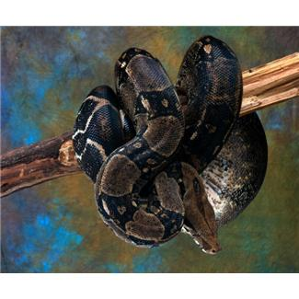

Chapter 3:
What Kind Of Environment Does The Reptile Need

Synopsis

Most reptiles need to be placed in suitable conditions where they can draw on the surroundings for the necessary heat for their bodies. This is because predominantly reptiles cannot generate body heat within the body, which is referred to as ectothermic.

The following are some of the elements that should be considered in the make up for the comfortable existence of the reptile pet:

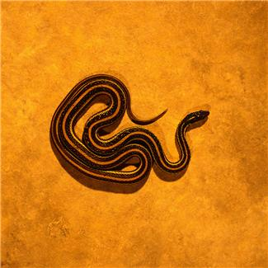

What Environment

As reptiles need to seek heat from its surroundings, there is a need to provide a variety of various scenarios within the confines of the cage or tank to accommodate such important temperature changes. Depending on the type of reptile being reared as a pet, the owner would have to be responsible and knowledgeable of its needs and try to cater to them.
There are three main groups within the reptile category and these would include the lizard and snake group which would require a tropical climate environment and then there is the turtle and tortoise group which have protective shells on their back and these would require an environment that contains a lot of water and cool rocks to bask on, and the last group would be the one that is predominantly comprised of crocodiles and alligators and this group would prefer to be in an environment that is actually dominated by water as they tend to spend most of their time in it. Equipped with this information the potential pet owner would have to decide if it is feasible and possible to create such environments to accommodate the chosen reptile pet comfortably and safely.
This preview copy ends here and to get the full product, please go to (the website URL ).

